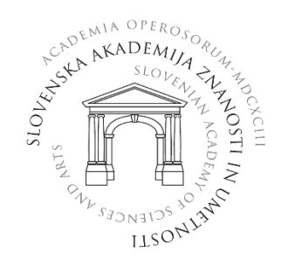

APPLICATION FORM

4. INTERACADEMIC SCIENTIFIC SYMPOSIUM
»Emerging Zoonoses – a Continuous Challenge«

First and last name:
Organization:
E-mail address:
Registration: | ☐ Thursday, October 6, 2022  ☐ Friday, October 7, 2022
Participation: | ☐ live  ☐ online  ☐ poster presentation

Please complete the registration form and send it to zoonoze@imi.si
no later than September 29, 2022.

